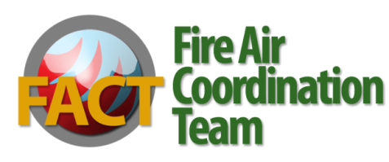
Fire Air Coordination Team
Mercury (Hg) Emissions from Wildland Fire
May 2008

Issue: Guidance on evaluating prescribed fire-related emissions of mercury (Hg) in project-level NEPA

Background: C. Wiedinmyer and H. Friedl of the National Center for Atmospheric Research published a paper in 2007 titled “Mercury Emission Estimates from Fires: An Initial Inventory for the United States.” The paper prompted the question of how land managers who use fire should address Hg emissions in land management and project planning.

Findings:
- Fire releases previously deposited Hg back into the air. Fire does not create or generate Hg.
- Atmospheric sources of Hg are:
  - natural (e.g., volcanoes, oceans, soil, vegetation),
  - anthropogenic (e.g., fossil fuel power plants, waste incinerators), and
  - re-emission of previously deposited Hg (e.g., wildland fire).
- The Wiedinmyer and Friedl (2007) study estimates that fires in the U.S. (including Alaska) re-emit an average of 44 metric tons per year of Hg (range is 20 to 65 with +or- 50% error) which is 5% of annual global biomass burning Hg emissions and >1% of annual global atmospheric Hg emissions.
- Health concerns develop when atmospheric Hg is deposited in water (rivers, lakes, wetlands) and subsequently converted to methyl-mercury (a neurotoxin for humans).
  - Hg released from fire is primarily in gaseous elemental form and thus generally not biologically available. This form of Hg can be airborne greater than a year.
  - Approximately 15% of Hg is released as particulate and reactive gaseous Hg which can be deposited in aquatic systems and converted to methyl mercury. The atmospheric lifetime of reactive particulate Hg is days to weeks.
  - SO₂ deposition stimulates the growth of sulfur reducing bacteria which methylate Hg, thus enhancing the biological availability of Hg.
- Overall, there are varied results from the studies, and there is uncertainty about the influence of fire on Hg mobilization. Studies have shown that even small amounts of mercury, if biologically available through methylation, can impact aquatic ecosystems and humans. It is widely recognized that fires re-release Hg to the air; it is not well understood how these emissions affect the Hg deposition and concentrations that affect health.
- The amount of Hg released can be greater from wildfires than prescribed fire. The amount of Hg released is a function of the quantity of biomass consumed and fire intensity. Wildfire typically consumes greater amounts of biomass than prescribed fire and will loft those emissions higher into the atmosphere.

Recommendations:
- Due to scientific uncertainty and large range of errors in the Hg emission factors, project-level or larger scale planning unit prescribed fire NEPA analyses should not estimate the amounts and effects of Hg emissions. Our efforts should continue to focus on sound smoke management to address the PM2.5 and other criteria pollutant effects on sensitive receptors and insure the National Ambient Air Quality Standards are met.
- Research is needed to reduce the uncertainty in estimating emissions of Hg from fire and the environmental effects of Hg mobilization prior to addressing them in NEPA analyses.
- If a concern is expressed during project scoping under NEPA, the decision maker and/or team leader should consult with the appropriate NEPA and air quality specialists before drafting a response. A risk assessment approach examining the trade-offs between emission levels from wildfire versus prescribed fire can also be included in the NEPA scoping process.

