How to Upgrade Your Desk Phone’s Firmware
When new firmware becomes available for your desk phones, an administrative reset of your phone will download and install the firmware. The directions listed below will help you perform the reset and select a new wallpaper if needed. The entire process will take 5 to 7 minutes and will involve several automatic restarts of your phone. If your phone does not upgrade to the newest firmware, please call the NIFC helpdesk at 208-387-5734 for assistance.

Perform an Administrative Reset

- To begin the upgrade, press the Settings button on your phone.
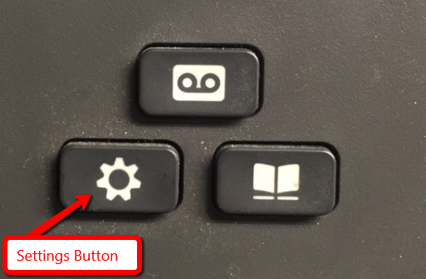

- Press the number 5 button on your phone to select Admin Settings.
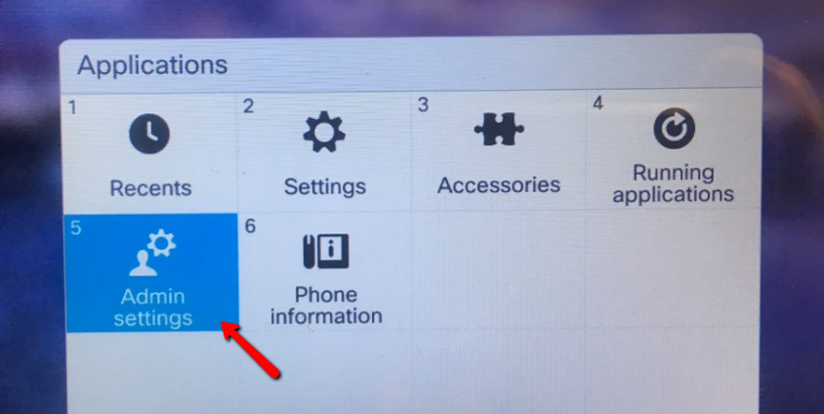

- Press the number 4 button on your phone to select Reset Settings.
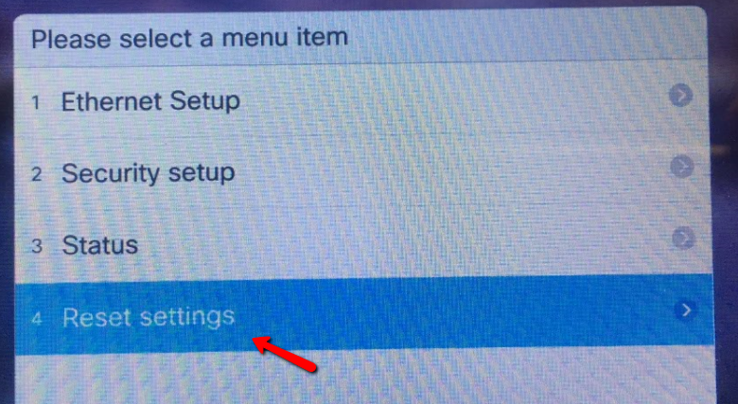

- Press the number 1 button on your phone to select Reset Device.
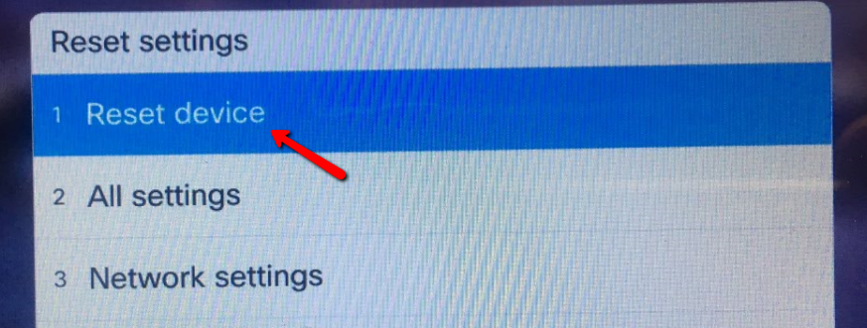

- Press the button below the Reset label.
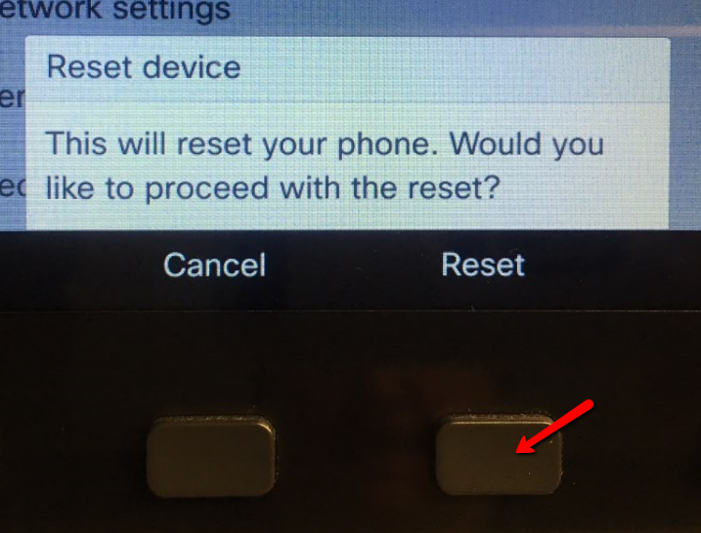

- After approximately 10 seconds, the phone will begin to reset. Once it finishes resetting, it will begin upgrading the firmware in the background, you will not see anything out of the ordinary for approximately two minutes. At that time, the message below will appear. You can wait a few seconds for the phone to restart, or you can press the Now button to start the firmware upgrade. Note: If your phone does not need a firmware upgrade, or fails to install the upgrade, you will not get the “Ready to Upgrade” notification pictured below.
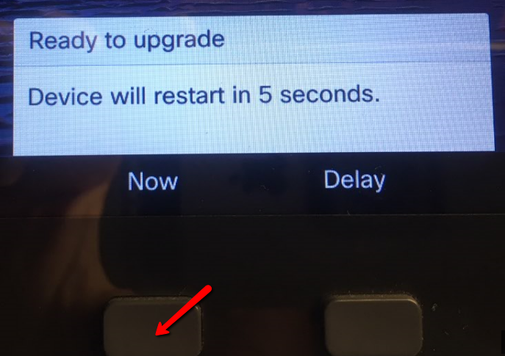
- Once your phone completes its firmware update, your new or modified existing wallpaper should appear. If any of the text on your wallpaper is difficult to read, you can select a new wallpaper using the following steps.

Select a Wallpaper

- Press the Settings button.

- Press the number 2 button on your phone to open Settings
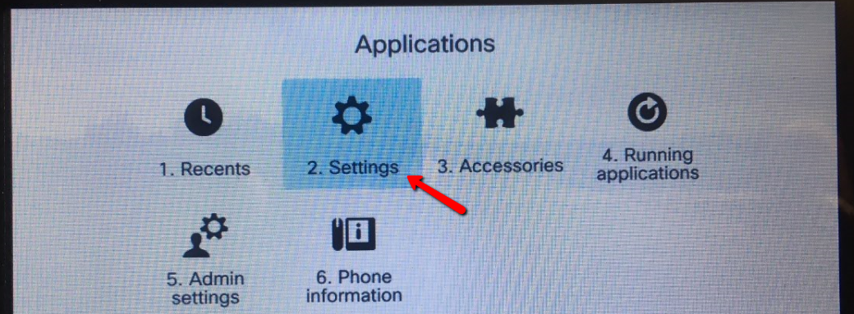

- Press the number 1 button on your phone to select Wallpaper
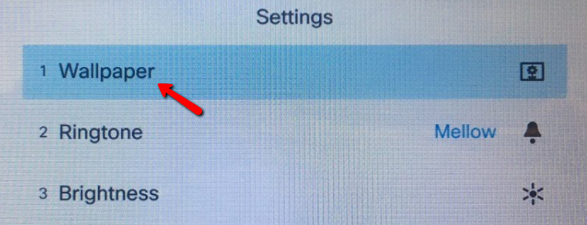

- Using the circular arrows button on your phone, move over and select a different wallpaper. Then press the button below the Preview label.
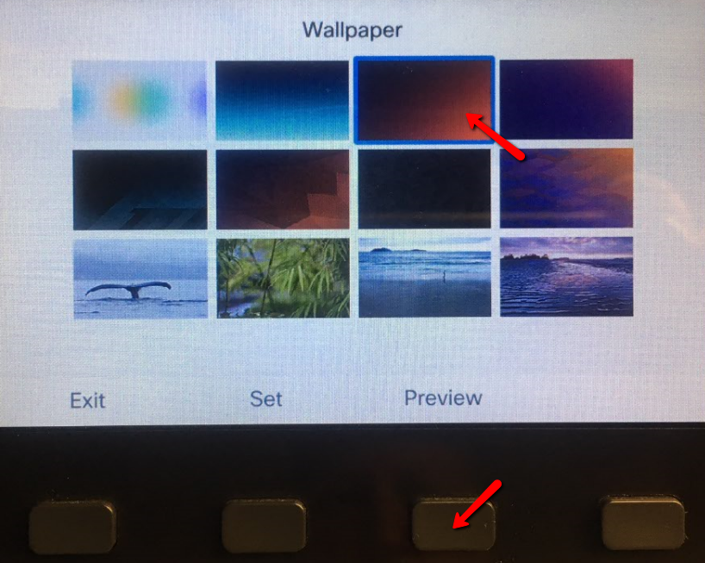

- If you can now see your text, press the button below the Set label to save this wallpaper.
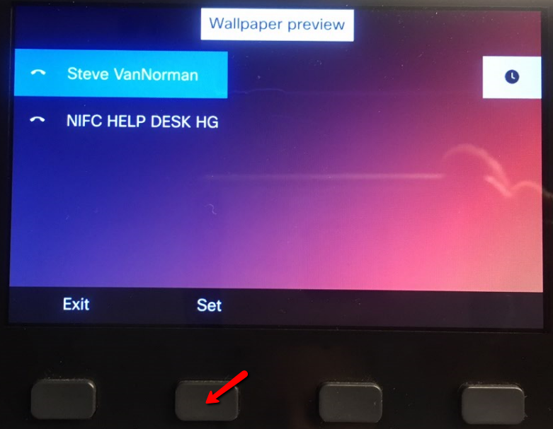

- Press Exit several times to return to the main phone screen.

